**Question 1.Create a React Application named “cricketapp” with the following components:**

1. ListofPlayers

* Declare an array with 11 players and store details of their names and scores using the map feature of ES6
* Filter the players with scores below 70 using arrow functions of ES6.

1. IndianPlayers
   1. Display the Odd Team Player and Even Team players using the Destructuring features of ES6
   2. Declare two arrays T20players and RanjiTrophy players and merge the two arrays and display them using the Merge feature of ES6

Display these two components in the same home page using a simple if else in the flag variable.

**CODE:**

IndianPlayers.js:

import React from 'react';

export function OddPlayers({ team }) {

  const [first, , third, , fifth] = team;

  return (

    <ul>

      <li>First: {first}</li>

      <li>Third: {third}</li>

      <li>Fifth: {fifth}</li>

    </ul>

  );

}

export function EvenPlayers({ team }) {

  const [, second, , fourth] = team;

  return (

    <ul>

      <li>Second: {second}</li>

      <li>Fourth: {fourth}</li>

    </ul>

  );

}

export function ListofIndianPlayers({ IndianPlayers }) {

  return (

    <ul>

      {IndianPlayers.map((player, index) => (

        <li key={index}>Mr. {player}</li>

      ))}

    </ul>

  );

}

ListOfPlayers.js:

import React from 'react';

function ListofPlayers({ players }) {

  return (

    <ul>

      {players.map((item, index) => (

        <li key={index}>

          Mr. {item.name} <span>({item.score})</span>

        </li>

      ))}

    </ul>

  );

}

export default ListofPlayers;

ScoreBelow70.js:

import React from 'react';

function Scorebelow70({ players }) {

  const filtered = players.filter(item => item.score < 70);

  return (

    <ul>

      {filtered.map((item, index) => (

        <li key={index}>

          Mr. {item.name} <span>({item.score})</span>

        </li>

      ))}

    </ul>

  );

}

export default Scorebelow70;

App.js:

import React from 'react';

import ListofPlayers from './ListofPlayers';

import Scorebelow70 from './Scorebelow70';

import { OddPlayers, EvenPlayers, ListofIndianPlayers } from './IndianPlayers';

function App() {

  const flag = false; //Can be changed to true to change output

  const players = [

    { name: 'Jack', score: 50 },

    { name: 'Michael', score: 70 },

    { name: 'John', score: 68 },

    { name: 'Elizabeth', score: 95 },

    { name: 'Chris', score: 100 },

    { name: 'Sachin', score: 61 },

    { name: 'Muthu', score: 64 },

    { name: 'Alok', score: 45 },

    { name: 'Rinku', score: 75 },

    { name: 'Robin', score: 60 },

    { name: 'Jadeja', score: 61 }

  ];

  const IndianTeam = ['First', 'Second', 'Third', 'Fourth', 'Fifth'];

  const T20Players = ['First Player', 'Second Player', 'Third Player'];

  const RanjiTrophyPlayers = ['Fourth Player', 'Fifth Player', 'Sixth Player'];

  const IndianPlayers = [...T20Players, ...RanjiTrophyPlayers];

  return (

    <div>

      {flag ? (

        <div>

          <h1>List of Players</h1>

          <ListofPlayers players={players} />

          <hr />

          <h1>List of Players having Scores Less than 70</h1>

          <Scorebelow70 players={players} />

        </div>

      ) : (

        <div>

          <h1>Indian Team</h1>

          <h2>Odd Players</h2>

          <OddPlayers team={IndianTeam} />

          <hr />

          <h2>Even Players</h2>

          <EvenPlayers team={IndianTeam} />

          <hr />

          <h2>List of Indian Players Merged:</h2>

          <ListofIndianPlayers IndianPlayers={IndianPlayers} />

        </div>

      )}

    </div>

  );

}

export default App;

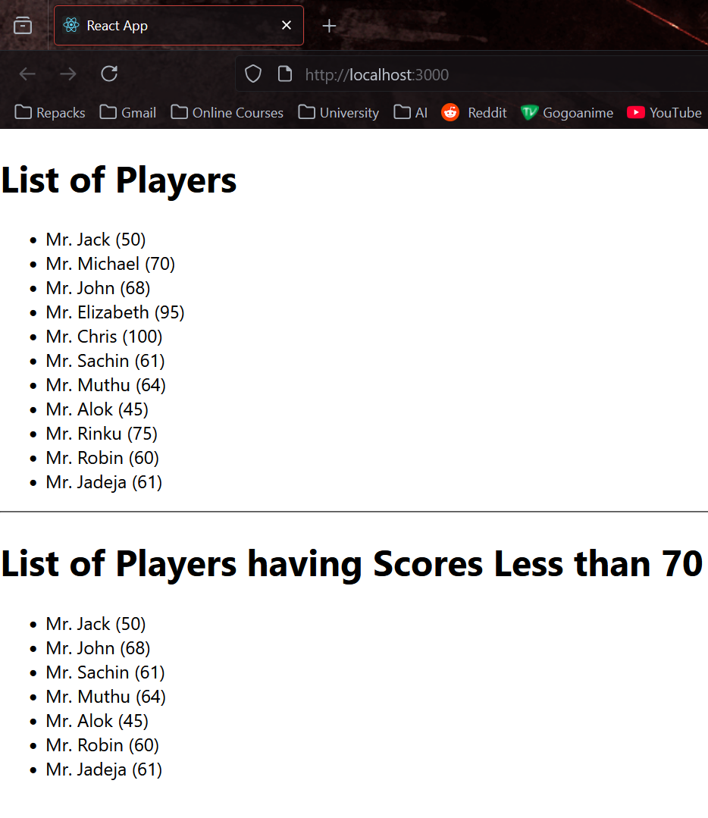**OUTPUT:**

**Question 2. Create a React Application named “officespacerentalapp” which uses React JSX to create elements, attributes and renders DOM to display the page.**

* Create an element to display the heading of the page.
* Attribute to display the image of the office space
* Create an object of office to display the details like Name, Rent and Address.
* Create a list of Object and loop through the office space item to display more data.
* To apply Css, Display the color of the Rent in Red if it’s below 60000 and in Green if it’s above 60000.

**CODE:**

OfficeList.js:

import React from 'react';

import './App.css'; // for styling

function OfficeList() {

  const heading = "Office Space , at Affordable Range";

  const imageSrc = "https://t4.ftcdn.net/jpg/03/84/55/29/360_F_384552930_zPoe9zgmCF7qgt8fqSedcyJ6C6Ye3dFs.jpg";

  const officeSpaces = [

    { Name: "DBS", Rent: 50000, Address: "Chennai" },

    { Name: "Regus", Rent: 65000, Address: "Bangalore" },

    { Name: "WeWork", Rent: 58000, Address: "Mumbai" },

    { Name: "SmartSpace", Rent: 72000, Address: "Delhi" }

  ];

  return (

    <div style={{ textAlign: 'center' }}>

      <h1>{heading}</h1>

      <img src={imageSrc} alt="Office Space" width="50%" height="50%" />

      <br /><br />

      {officeSpaces.map((item, index) => {

        const rentColor = item.Rent <= 60000 ? "textRed" : "textGreen";

        return (

          <div key={index} className="card">

            <h2>Name: {item.Name}</h2>

            <h3 className={rentColor}>Rent: Rs. {item.Rent}</h3>

            <h3>Address: {item.Address}</h3>

          </div>

        );

      })}

    </div>

  );

}

export default OfficeList;

App.css:

.textRed {

  color: red;

  font-weight: bold;

}

.textGreen {

  color: green;

  font-weight: bold;

}

.card {

  border: 1px solid #ccc;

  margin: 20px auto;

  padding: 15px;

  width: 50%;

  border-radius: 10px;

  background-color: #f9f9f9;

}

.responsive-image {

  width: 100%;

  max-width: 600px;

  height: auto;

  border-radius: 10px;

  margin-top: 20px;

}

App.js:

import React from 'react';

import './App.css';

import OfficeList from './OfficeList';

function App() {

  return (

    <div className="App">

      <OfficeList />

    </div>

  );

}

export default App;

**OUTPUT:**

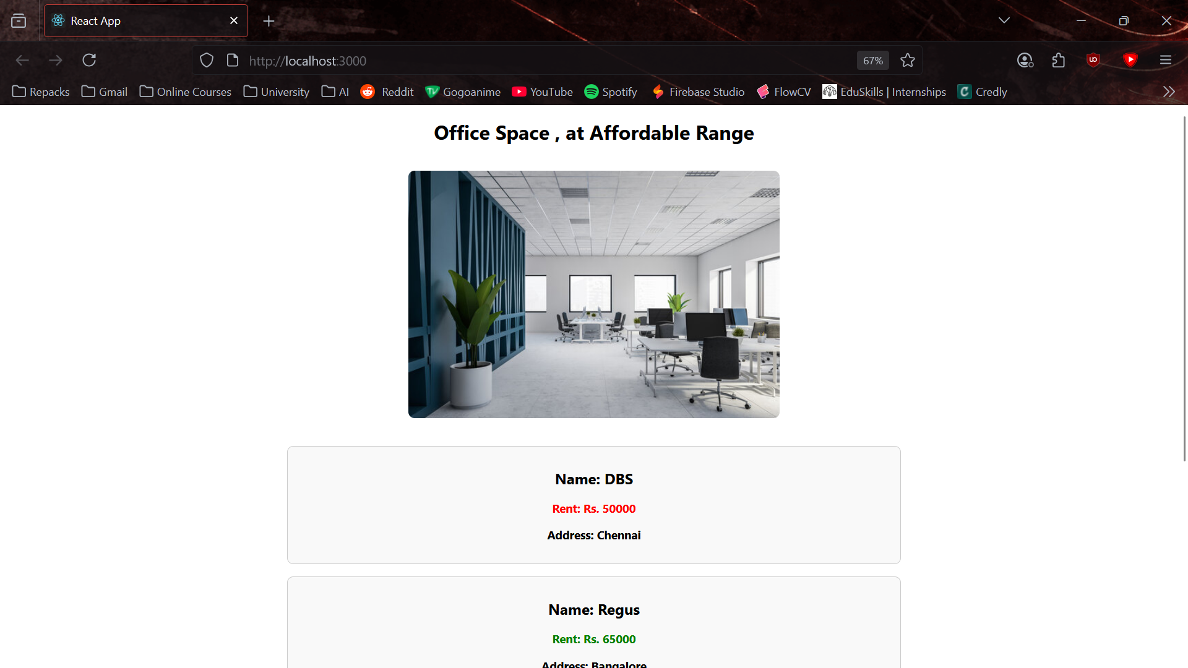

**Question 3. Create a React Application “eventexamplesapp” to handle various events of the form elements in HTML.**

1. Create “Increment” button to increase the value of the counter and “Decrement” button to decrease the value of the counter. The “Increase” button should invoke multiple methods.
   1. To increment the value
   2. Say Hello followed by a static message.
2. Create a button “Say Welcome” which invokes the function which takes “welcome” as an argument.
3. Create a button which invokes synthetic event “OnPress” which display “I was clicked”
4. Create a “CurrencyConvertor” component which will convert the Indian Rupees to Euro when the Convert button is clicked.
5. Handle the Click event of the button to invoke the handleSubmit event and handle the conversion of the euro to rupees.

**CODE:**

CurrencyConverter.js:

import React, { useState } from "react";

function CurrencyConverter() {

  const [amount, setAmount] = useState("");

  const [currency, setCurrency] = useState("");

  const handleSubmit = (e) => {

    e.preventDefault();

    if (currency.toLowerCase() === "euro") {

      const rupees = parseFloat(amount) * 80;

      alert(`Converting to Euro Amount is ${rupees}`);

    } else {

      alert("Please enter a valid currency (Euro)");

    }

  };

  return (

    <div style={{ marginTop: "30px" }}>

      <h2 style={{ color: "green" }}>Currency Convertor!!!</h2>

      <form onSubmit={handleSubmit}>

        <label>

          Amount:

          <input

            type="text"

            value={amount}

            onChange={(e) => setAmount(e.target.value)}

          />

        </label>

        <br />

        <label>

          Currency:

          <input

            type="text"

            value={currency}

            onChange={(e) => setCurrency(e.target.value)}

          />

        </label>

        <br />

        <button type="submit">Submit</button>

      </form>

    </div>

  );

}

export default CurrencyConverter;

App.js:

import React, { useState } from "react";

import "./App.css";

import CurrencyConverter from "./CurrencyConverter";

function App() {

  const [count, setCount] = useState(0);

  const increment = () => {

    setCount(prev => prev + 1);

  };

  const sayHello = () => {

    alert("Hello! Member1");

  };

  const handleIncrease = () => {

    increment();

    sayHello();

  };

  const handleDecrease = () => {

    setCount(prev => prev - 1);

  };

  const greet = (msg) => {

    alert(msg);

  };

  const handleClick = (e) => {

    alert("I was clicked");

  };

  return (

    <div className="App">

      <h1>{count}</h1>

      <button onClick={handleIncrease}>Increment</button>

      <br />

      <button onClick={handleDecrease}>Decrement</button>

      <br />

      <button onClick={() => greet("welcome")}>Say welcome</button>

      <br />

      <button onClick={handleClick}>Click on me</button>

      <br />

      <CurrencyConverter />

    </div>

  );

}

export default App;

**OUTPUT:**

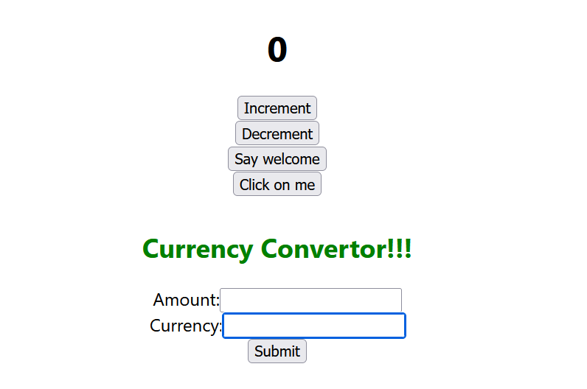

**Question 4. Create a React Application named “ticketbookingapp” where the guest user can browse the page where the flight details are displayed whereas the logged in user only can book tickets.**

The Login and Logout buttons should accordingly display different pages. Once the user is logged in the User page should be displayed. When the user clicks on Logout, the Guest page should be displayed.

**CODE:**

App.js:

import React, { useState } from 'react';

function LoginButton(props) {

  return <button onClick={props.onClick}>Login</button>;

}

function LogoutButton(props) {

  return <button onClick={props.onClick}>Logout</button>;

}

function GuestGreeting() {

  return (

    <div>

      <h2>Please sign up to book your tickets.</h2>

      <FlightDetails />

    </div>

  );

}

function UserGreeting() {

  return (

    <div>

      <h2>Welcome back!</h2>

      <FlightDetails />

      <BookingForm />

    </div>

  );

}

function Greeting(props) {

  const isLoggedIn = props.isLoggedIn;

  return isLoggedIn ? <UserGreeting /> : <GuestGreeting />;

}

function FlightDetails() {

  return (

    <div>

      <h3>Available Flights</h3>

      <ul>

        <li>Delhi → Mumbai @ ₹4000</li>

        <li>Bangalore → Chennai @ ₹2500</li>

        <li>Kolkata → Goa @ ₹3500</li>

      </ul>

    </div>

  );

}

function BookingForm() {

  const handleSubmit = (e) => {

    e.preventDefault();

    alert('Tickets booked successfully!');

  };

  return (

    <form onSubmit={handleSubmit}>

      <h3>Book Your Flight</h3>

      <label>

        Passenger Name:

        <input type="text" required />

      </label><br />

      <label>

        Flight:

        <select required>

          <option>Delhi → Mumbai</option>

          <option>Bangalore → Chennai</option>

          <option>Kolkata → Goa</option>

        </select>

      </label><br />

      <button type="submit">Book</button>

    </form>

  );

}

function App() {

  const [isLoggedIn, setIsLoggedIn] = useState(false);

  const handleLogin = () => setIsLoggedIn(true);

  const handleLogout = () => setIsLoggedIn(false);

  const button = isLoggedIn

    ? <LogoutButton onClick={handleLogout} />

    : <LoginButton onClick={handleLogin} />;

  return (

    <div className="App">

      <h1>Ticket Booking App</h1>

      {button}

      <Greeting isLoggedIn={isLoggedIn} />

    </div>

  );

}

export default App;

**OUTPUT:**

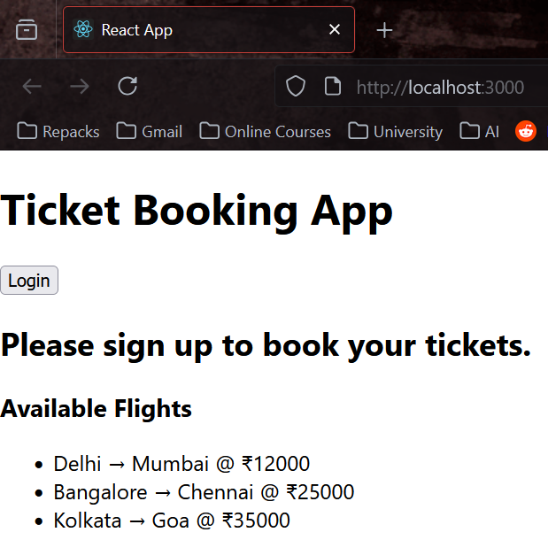

**Question 5. Create a React App named “bloggerapp” in with 3 components.**

1. Book Details
2. Blog Details
3. Course Details

Implement this with as many ways possible of Conditional Rendering.

**CODE:**

components/ BlogDetails.js:

import React from 'react';

function BlogDetails({ blogs }) {

  return (

    <div className="v1">

      <h1>Blog Details</h1>

      {blogs &&

        blogs.map((blog, idx) => (

          <div key={idx}>

            <h3>{blog.title}</h3>

            <strong>{blog.author}</strong>

            <p>{blog.content}</p>

          </div>

        ))}

    </div>

  );

}

export default BlogDetails;

components/ BookDetails.js:

import React from 'react';

function BookDetails({ books }) {

  return (

    <div className="st2">

      <h1>Book Details</h1>

      <ul>

        {books.length > 0 ? (

          books.map(book => (

            <div key={book.id}>

              <h3>{book.bname}</h3>

              <h4>{book.price}</h4>

            </div>

          ))

        ) : (

          <p>No books available.</p>

        )}

      </ul>

    </div>

  );

}

export default BookDetails;

components/ CourseDetails.js:

import React from 'react';

function CourseDetails({ courses }) {

  let content;

  if (courses && courses.length > 0) {

    content = courses.map((course, idx) => (

      <div key={idx}>

        <h3>{course.name}</h3>

        <p>{course.date}</p>

      </div>

    ));

  } else {

    content = <p>No courses found.</p>;

  }

  return (

    <div className="mystyle1">

      <h1>Course Details</h1>

      {content}

    </div>

  );

}

export default CourseDetails;

data.js:

export const books = [

  { id: 101, bname: 'Master React', price: 670 },

  { id: 102, bname: 'Deep Dive into Angular 11', price: 800 },

  { id: 103, bname: 'Mongo Essentials', price: 450 },

];

export const courses = [

  { name: 'Angular', date: '4/5/2021' },

  { name: 'React', date: '6/3/2021' },

];

export const blogs = [

  {

    title: 'React Learning',

    author: 'Stephen Biz',

    content: 'Welcome to learning React!',

  },

  {

    title: 'Installation',

    author: 'Schwezdenier',

    content: 'You can install React from npm.',

  },

];

App.js:

import React from 'react';

import BookDetails from './components/BookDetails';

import BlogDetails from './components/BlogDetails';

import CourseDetails from './components/CourseDetails';

import { books, blogs, courses } from './data';

function App() {

  return (

    <div style={{ display: 'flex', justifyContent: 'space-around' }}>

      <BookDetails books={books} />

      <BlogDetails blogs={blogs} />

      <CourseDetails courses={courses} />

    </div>

  );

}

export default App;

**OUTPUT:**

